Pandas DataFrame Operations

1. Display the First 5 Rows (Head)
Code:
import pandas as pd
df = pd.read_csv("auto-mpg.csv")
print("First 5 Rows:")
print(df.head())
Output:

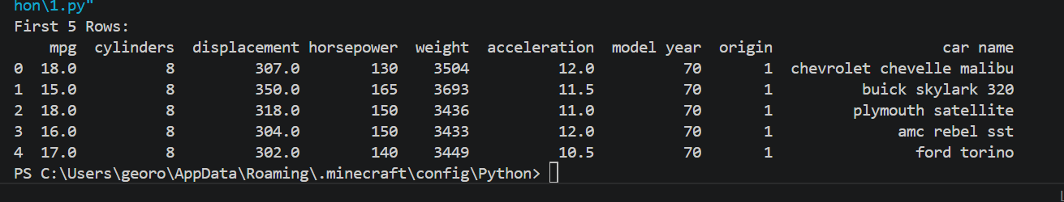

2. Display the Last 5 Rows (Tail)
Code:
import pandas as pd
df = pd.read_csv("auto-mpg.csv")
print("Last 5 Rows:")
print(df.tail())
Output:
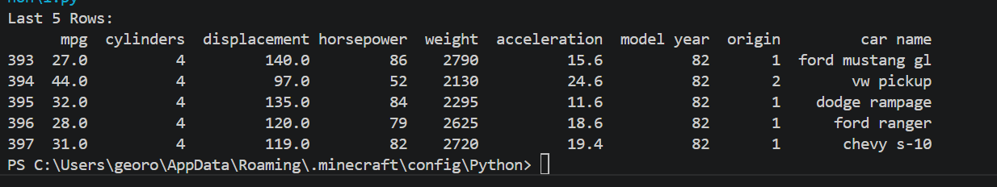

3. Horizontal and Vertical Concatenation
Code:
import pandas as pd
df = pd.read_csv("auto-mpg.csv")
df1=df.iloc[:200]
df2=df.iloc[200:]
vertical_concat=pd.concat([df1,df2],ignore_index=True)
print(vertical_concat)
left=df.iloc[:,:4]
right=df.iloc[:,4:]
horizontal_concat=pd.concat([left,right],axis=1)
print(horizontal_concat)
Output:

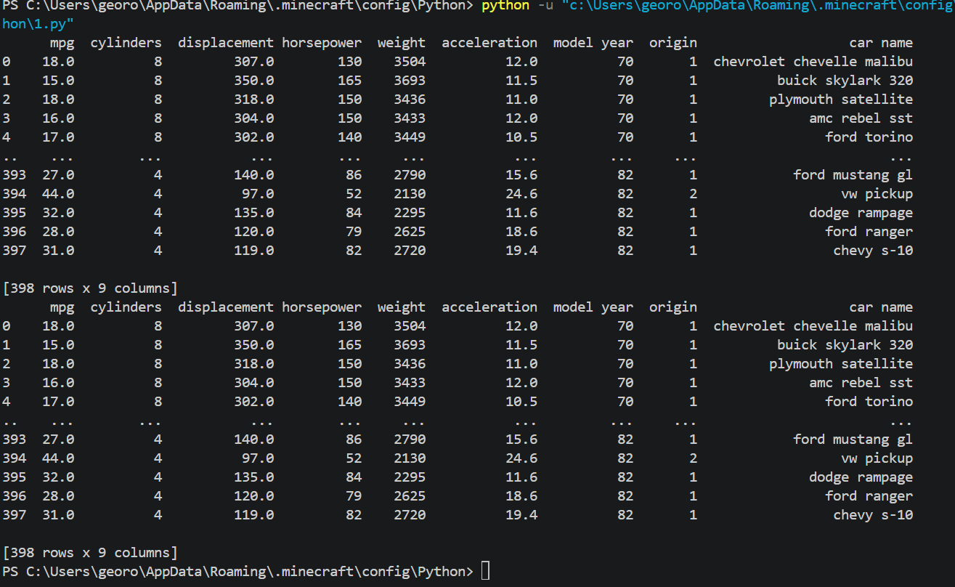4. Merge Two DataFrames
Code:
import pandas as pd
df=pd.read_csv("auto-mpg.csv")
df1=df[['car name','mpg']]
df2=df[['car name','horsepower']]
merged=pd.merge(df1,df2,on='car name',how='inner')
print(merged)
Output:

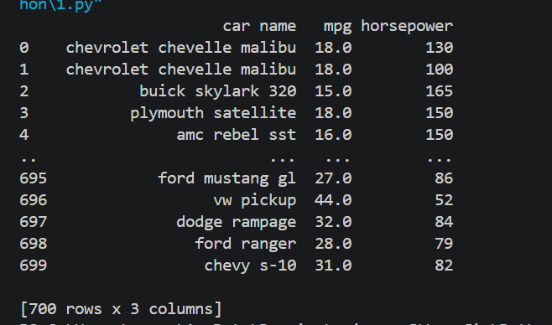

5. Add a New Column
Code:
import pandas as pd
df = pd.read_csv("auto-mpg.csv")
df["horsepower"] = pd.to_numeric(df["horsepower"], errors="coerce")
df["Power_to_Weight"] = df["horsepower"] / df["weight"]
print(df)
Output:

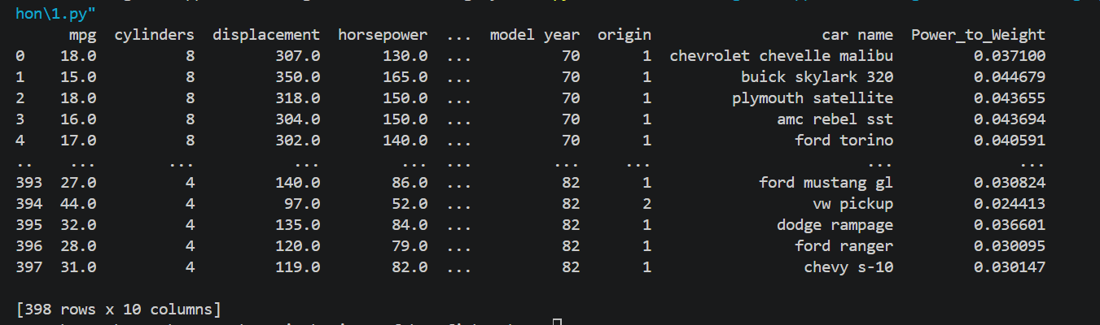6. Descriptive Statistics
Code:
import pandas as pd
df=pd.read_csv("auto-mpg.csv")
print(df.describe())
Output:

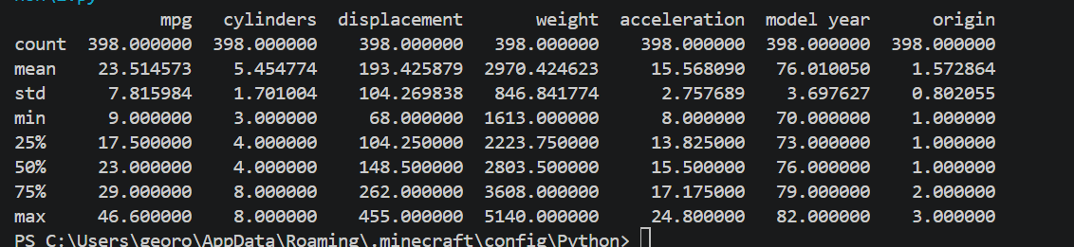7. Value Counts
Code:
import pandas as pd
df=pd.read_csv("auto-mpg.csv")
print(df['origin'].value_counts())
Output:

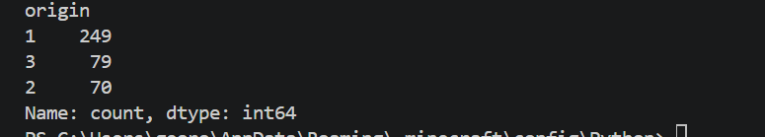

8. Stack and Unstack
Code:
import pandas as pd
df=pd.read_csv("auto-mpg.csv")
small_df=df[['mpg','horsepower','weight']].head()
stacked=small_df.stack()
print(stacked)
print(stacked.unstack())
Output:

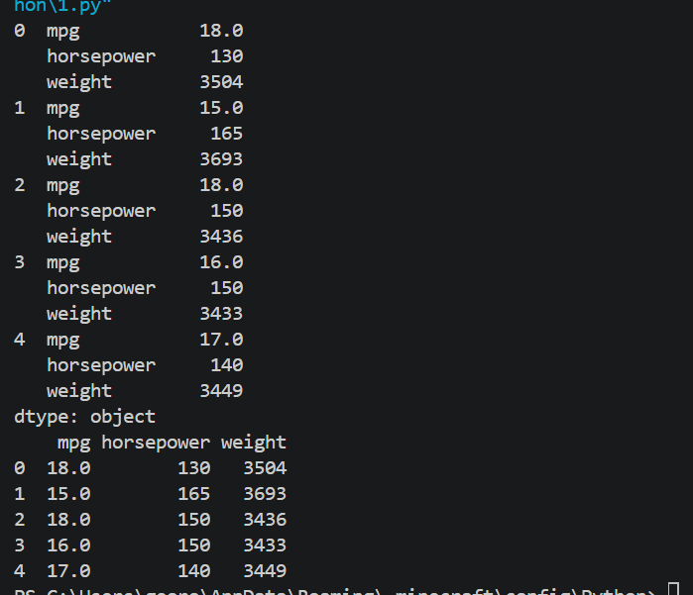

9. Series Concatenation with Keys
Code:
import pandas as pd
df=pd.read_csv("auto-mpg.csv")
series1=df['mpg'].head()
series2=df['horsepower'].head()
combined=pd.concat([series1,series2],keys=['MPG','Horsepower'])
print(combined)
Output:

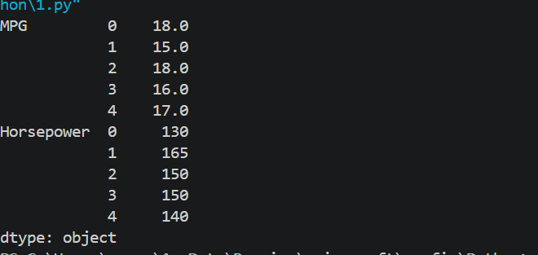

10. Sort the DataFrame
Code:
import pandas as pd
df=pd.read_csv("auto-mpg.csv")
sorted_df=df.sort_values(by='mpg',ascending=False)
print(sorted_df)
Output:
